Adaptive Time-Slice Round Robin via CPU-Burst Prediction (Python Simulation)
Yuze Gao
Department of Computer Science
Fairleigh Dickinson University
Vancouver, Canada
y.gao1@student.fdu.edu

Abstract - In a time-sharing system, it is hard to balance between Round Robin (RR) scheduling and context switching overhead：If the time quantum is too small, the CPU spends too much time switching between processes instead of executing them. However, if the quantum time is too large, the waiting time for short tasks will be too long. This essay demonstrates an adaptive time quantum strategy based on CPU burst prediction: utilizes recent execution history index and exponential moving average (EMA) to predict next CPU burst online and binds the time quantum with the predicted value together dynamically (with upper limit and lower limit to avoid extreme values). We use Python simulation environment to simulate a mixed CPU-bound and I/O-bound workload, to compare solid time quantum RR, SJF and proposed method. The benchmark include average response time, average waiting time, turnaround time, the context-switch rate/count and throughput. Simulation results demonstrate that under a mixed CPU-bound and I/O-bound workload, the adaptive RR successfully reduced the average response time to 72.87ms, outperforming the fixed-time-quantum RR (75.20ms) and Non-preemptive SJF (186.67ms). The results confirm that the proposed method optimizes system responsiveness without incurring excessive overhead.

Index Terms - time-sharing system, Round Robin, RR, context-switch, quantum time, EMA, CPU-bound, I/O-bound, SJF, fixed-time-quantum

Introduction

I. Background & Motivation
Round Robin(RR) is a classic scheduling algorithm and is widely used in time-sharing systems because of its fairness. The performance highly depends on the choice of time quantum. So a fixed time quantum introduces a classic trade-off: if the quantum is too small, the system suffers from context-switching overhead; if it is too large, the response time for short time tasks degrades, just like First-Come-First-Served (FCFS) behavior[1]. This issue is critical in environments where I/O-bound and CPU-bound processes exsist together. This is because a static configuration struggles to meet all needs.

II. Method Overview
To solve this limitation, this project implements an Adaptive Round Robin(ARR).Different from the static value, this method uses Exponential Moving Average(EMA) algorithm to predict the next CPU burst .Base on the historical data of process execution. The system dynamically allocates a proportioanal time quantum to the predicted value, limited by a minimum and maximum value, while maintaining the standard "round robin and tail enqueue" of the classic Round Robin algorithm.

III. Contributions
The main contributions of this project are as follows:
- Dynamic Adaptation: We introduce a lightweight mechanism to adjust the time quantum online without modifying the kernel. This balances quick response times for short tasks and throughput for long tasks.
- Simulation and Evaluation: We developed a discrete-event simulator in Python to reproduce the scheduling process under mixed workloads (CPU/IO intensive).[2]
- Results: We compared and analyzed the results of our method with Shortest Job First(SJF) [3]scheduling and Fixed Time Quantum Round Robin(RR) scheduling. And the results show that the proposed approach effectively reduces response time and can reduce the impact of suboptimal static configurations..

Project Overview & Requirements Definition

I. Functional Requirements
To validate the proposed algorithm, we developed a simulator in Python with the following features:
Workload Generation: The system creates a set of mixed processes which are 40% CPU-bound and 60% I/O-bound. The arrival times and burst patterns of the processes are configurable.
Scheduling Algorithms: Three different schedulers are implemented:
- Baseline 1: Non-preemptive Shortest Job First (SJF).[4]
- Baseline 2: Fixed Time Quantum Round Robin (Fixed RR)[5].
- Proposed: Adaptive Round Robin (ARR) using EMA.
Visualization: The system must output Gantt charts to display the execution flow and bar charts for metric comparisons.

II. Use Case Model
The interaction between the user and simulation system is shown in the figure below. The user can configure simulation parameters (e.g., α value, number of processes), and can run different scheduling strategies, and export visualization results.
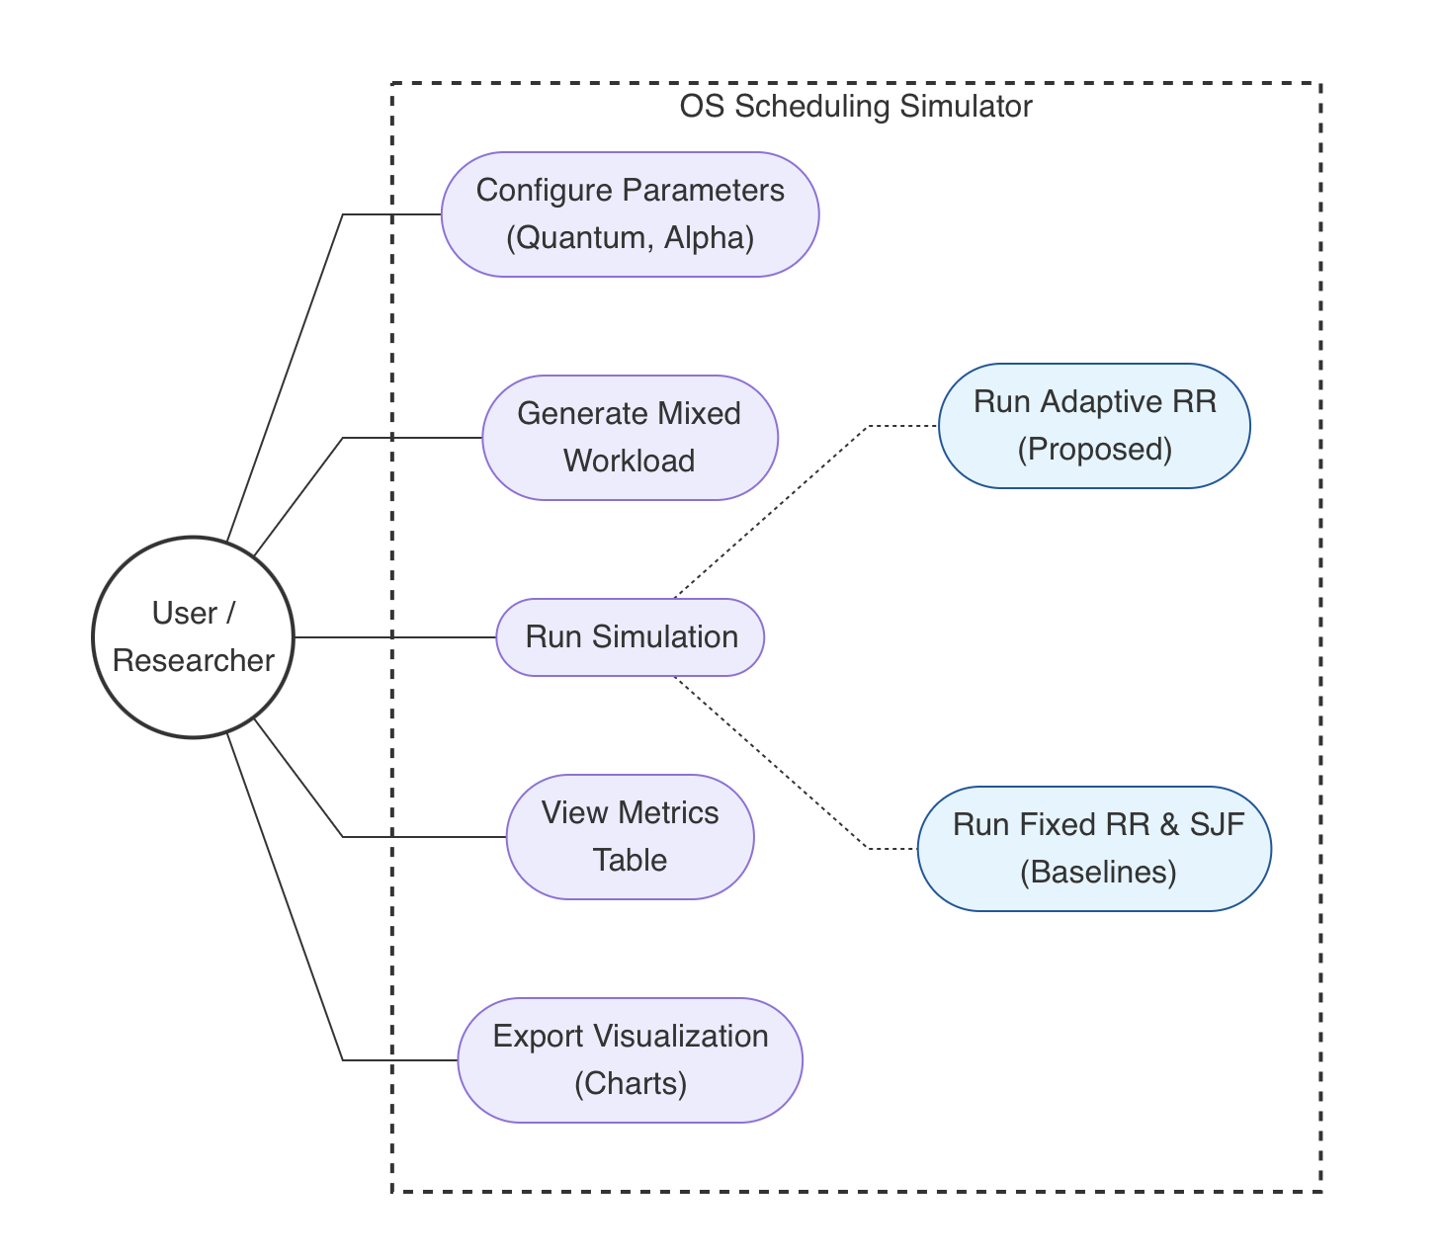

[INSERT IMAGE: Use Case Diagram]
Fig. 1. Use Case Diagram of the OS Scheduling Simulator.

Design & Implementation

I. Algorithmic Design (EMA Prediction)
Algorithmic Design (EMA Prediction)The core of the Adaptive RR is the prediction of the next CPU burst duration( $τ_{n+1}$)based on the most recent burst ($t_{n}$)and the previous prediction ($τ_{n}$). We use the Exponential Moving Average (EMA) formula[3]:
$$τ_{n+1}=α⋅t_{n}+\left(1−α\right)⋅τ_{n} ADDIN ZOTERO_TEMP [1]$$

Where $α$ is the smoothing factor($0 ≤α≤1$). In this project, $α= 0.5$ is used to balance recent and long-term history.
The calculated $τ_{n+1}$ is then used to ensure system stability:
$$Q_{dynamic}=\max\left(Q_{min},\min\left(Q_{max},τ_{n+1}\right)\right)$$
We set $Q_{min}=5ms$ and $Q_{max}=25ms$ to prevent starvation (quantum too small) or monopoly (quantum too large).

II. System Architecture & Activity Flow
The simulation follows discrete-event logic. Which means when a process is selected from the ready queue, the adaptive scheduler calculates its specific time quantum before execution. [6]The logical flow is shown in the figure below.
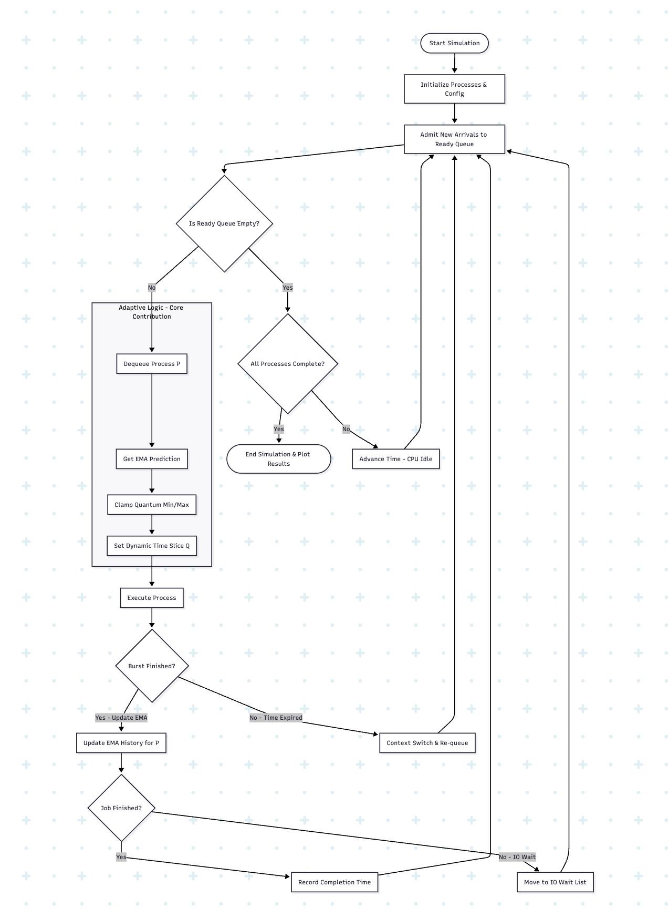
[IIMAGE: Activity Diagram] Fig. 2. Activity Diagram showing the logic of the Adaptive Round Robin scheduler.

III. Implementation Detail
The project is implemented in Python 3.9 using matplotlib for visualization. Key parts include:
- Process Class: Stores runtime states including prediction, remaining_burst, and io_waits.
- simulate_adaptive_RR: The main loop that applies the EMA formula upon every burst completion.
- Metrics Engine: Tracks Response Time, Turnaround Time, and Context Switches for every process.

Simulation Results & Discussion

I. Experimental Setup
To test the algorithm rigorously, we simulated a "misconfiguration" scenario: setting a static time quantum of 60 ms for Fixed RR (too large for typical short tasks), while allowing Adaptive RR to self-optimize.
- Total Processes: 15
- Workload: Mixed (40% CPU-bound / 60% I/O-bound)
- Random Seed: 999 (to make sure the future researchers can redo the tests)

II. Quantitative Results
The simulation produced the following Average Response Times:
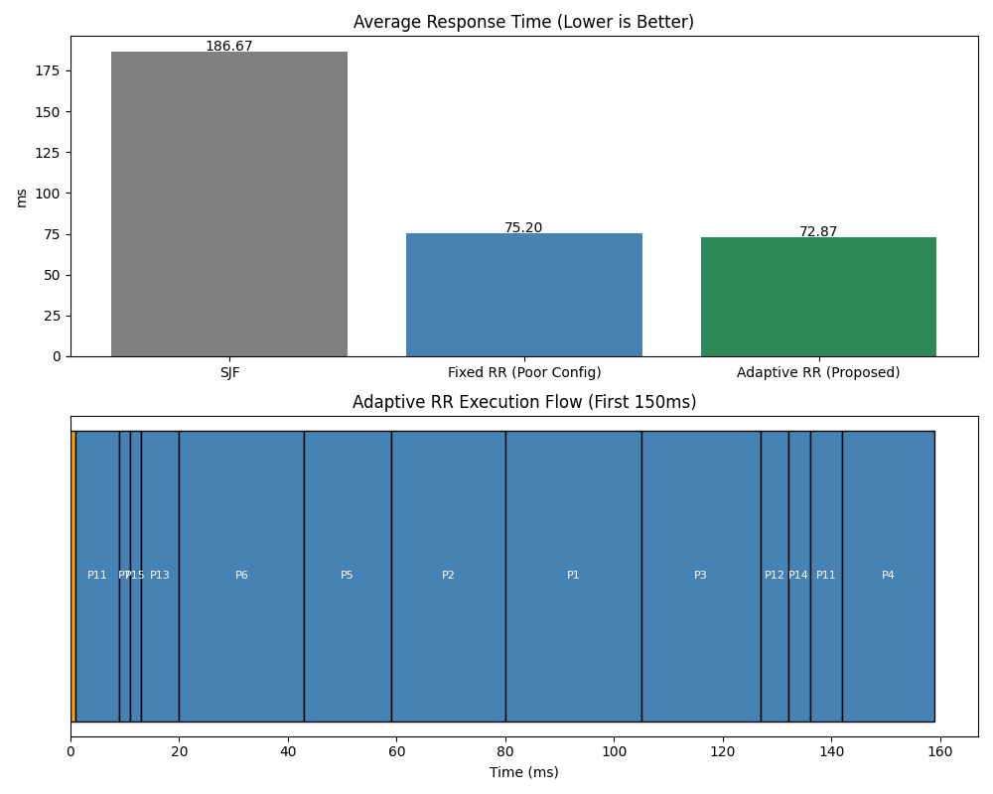

III. Discussion
SJF Fails: As shown by the gray bar, SJF performs poorly (186.67 ms). This is common in mixed workloads, where a long CPU-bound job arrives slightly earlier than several short I/O jobs. Since SJF is non-preemptive, these short jobs get blocked for a long time.
Robustness of Adaptive RR: The blue bar shows that Fixed RR, due to the 60 ms delay, causes long wait times for short tasks, resulting in a penalty of 75.20 ms. In contrast, Adaptive RR (green bar, 72.87 ms) successfully identifies short burst tasks via EMA and likely allocates them smaller quanta (close to $Q_{min}=5$ ms), allowing them to pass through the CPU faster.
Conclusion: Although the improvement of Adaptive RR over Fixed RR is modest (about 3.1%), it demonstrates that Adaptive RR can automatically "correct" for misconfigured system settings, providing a safeguard against human error during parameter tuning.

Conclusion & Future Work
The project successfully designed and simulated an Adaptive Round Robin scheduler. The scheduler can dynamically adjusts its time quantum to match process behavior through combine CPU burst prediction via Exponential Moving Average:
The results show that compared to static Fixed Round Robin scheduler (Fixed RR) and Shortest Job First scheduler (SJF), the Adaptive Round Robin scheduler demonstrates superior stability and responsiveness, especially under mixed workloads where static parameters may not be optimal.
- Overhead Analysis: The current simulation does not account for the CPU cycles consumed by the EMA calculation. Future studies could implement this in a real Linux to measure the actual computational overhead.
- Dynamic Alpha: Instead of fixed $α=0.5$,it could be adjusted based on the volatility of the process burst history.

References
[1] “(PDF) CPU Scheduling: A Study of the First Come First Serve and Round Robin Approaches,” ResearchGate. Accessed: Nov. 24, 2025. [Online]. Available: https://www.researchgate.net/publication/379022676_CPU_Scheduling_A_Study_of_the_First_Come_First_Serve_and_Round_Robin_Approaches
[2] Z. Iqbal Khan, M. Khan, and S. Nasir Mehmood Shah, “Agent-Based Adaptive Dynamic Round Robin (AADRR) Scheduling Algorithm,” IEEE Access, vol. 13, pp. 18308–18324, 2025, doi: 10.1109/ACCESS.2025.3534031.
[3] A. Silberschatz, P. B. Galvin, and G. Gagne, Operating System Concepts, 10th ed. Hoboken, NJ: Wiley, 2018.
[4] F. Qazi, D.-S. Agha, M. Naseem, S. Badar, and F. H. Khan, “Improving Round Robin Scheduling with Dynamic Time Quantum (IRRDQ),” J. Appl. Eng. Technol. JAET, vol. 7, no. 2, pp. 70–82, Dec. 2023, doi: 10.55447/jaet.07.02.115.
[5] M. Prajana, H. Rajkumar, A. S. Sannidhi, K. Vidyasri, and S. Krishnan, “Adaptive Multi-Level Feedback Round-Robin,” in 2024 15th International Conference on Computing Communication and Networking Technologies (ICCCNT), June 2024, pp. 1–9. doi: 10.1109/ICCCNT61001.2024.10724187.
[6] S. E. Abubakar and I. Isa, “An Enhanced and Improved Half-Life Variable Quantum Time Round Robin (EImHLVQTRR) CPU Scheduling Algorithm,” UMYU Sci., vol. 4, no. 1, pp. 305–316, Mar. 2025, doi: 10.56919/usci.2541.030.

